**Phase 3: Report a review on the related work**

**Team Report by Team OLAPPED CSCI 6401-01**

**Team Name :-** OLAPPED

**Course :-** Data Mining

**Instructor :-** Prof. Shivanjali Khare

**Course ID :-** CSCI-6401-01

**Session :-** Fall 2023

**Assignment :-** Phase 4: Modeling data

**1. Team Name :-** OLAPPED

**Team Member Names :-**

(1) Sean Vargas – [svarg1@unh.newhaven.edu](mailto:svarg1@unh.newhaven.edu)

(2) Kaylie N Neal – [kneal5@unh.newhaven.edu](mailto:kneal5@unh.newhaven.edu)

(3) Prashant Rana – [prana4@unh.newhaven.edu](mailto:prana4@unh.newhaven.edu)

(4) Rajdeep Bhattacharya – [rbhat6@unh.newhaven.edu](mailto:rbhat6@unh.newhaven.edu)

**2. Selected Dataset :-**

**Description of the selected dataset that we want to work with –**

The Data Set is named “trends” as it represents the Google Search Trends for a period of 20 years (2001 - 2020), pointing out the **[Top 5 Google Searches (Search Queries)]** by **[Categories]** with their **[Global Ranks]** and the ranks for the **[Top Countries]** by **[Year].**

It has 5 Attributes (represented by 5 columns) namely **location, year, category, rank and query**. And 26956 Data Points (represented by 26956 rows).

**Research Question :-**

**The Research Question: -** How can the patterns and trends in the **Google Search Engine Queries Dataset** be used to identify better rules for finding the most promising **Keywords (Search Queries)** and **Topics (Categories)** for showing more relevant **Search Results** in the future and targeting the relevant **SERPs (Search Engine Result Pages)** for **Ad Suggestions** by **timings (Seasonality)** and **locations (Geography)** for **Customer/Viewer Satisfaction** and higher **Ad Revenues**.

**3. List of data mining techniques used**

For this phase we have used 2 Data Modelling techniques, Linear Regression and Isotonic regression. We will be using more Data models in our optimization phase.

1. **Linear regression**

Linear regression is a data modelling technique that allows us to model data based on linear data attributes. In linear regression, the data are plotted using scatter plots and a linear line is drawn which best fits the data on the scatter plots. For our linear regression model, we try to form our linear model with expression y = b1x + b0, where b1 is the coefficient of x I.e. slope of our line and b0 is the y-intercept. We calculate the coefficients from our given data x and y which is known to us from our dataset I.e. x as year and y as Frequency of each category (Calculated by grouping by category).

**Parameters**: y-intercept (b0) is the slope intercept which forms the equation of the line, slope (b1) is the measure of the tangent of the angle made by the line with x-axis.

**Hyperparameters**: Lasso and Ridge regularization to prevent overfitting, optimization algorithms such as gradient descent or ordinary least squares, learning rate can be set if gradient descent is used.

1. **Isotonic regression**

Isotonic Regression is a type of regression analysis that focuses on modeling the relationship between a single independent variable and a dependent variable while maintaining a monotonic (non-decreasing or non-increasing) relationship between them. We have used isotonic regression from sci-kit learn library of python. For evaluation metric, we used mean squared error from scikit.metrics. Here, also we are using scatterplot to plot our data with x as year and y as Frequency of each category over period of time.

**Parameters**: isotonic segmentations represent the region where the function is constrained to be monotonic.

**Hyperparameters**: increasing or decreasing, we can specify whether we want increasing or decreasing monotonic regression; Y-min and Y-max, minimum and maximum values the fitted function should not go beyond; out of bound strategy, specifies how to handles predictions that go beyond specified constraints.

**4. Hardware used:**

Hardware specification being used for data mining project:

- CPU: Intel Core i7

- RAM: 16 GB

- Storage: 512 GB HDD

Software specifications being used:

- IDE: Visual Studio Code

- Programming Language: Python 3.8

- Libraries used: Pandas, Numpy, Matplotlib, Sci-kit learn

**5. Outcomes:**

For our modelling, we plotted Linear and Isotonic regression for top 5 unique categories. For measuring our models, we used Root Mean Squared Error. While rmse between 0.2 and 0.9 is considered a good model. But due to deficiency of good datas in our dataset we got rmse along 1.8 to 2.9. Based on these values, we considered the lowest rmse value a good candidate for our models. Hence, we selected top 5 categories based on those metrics and plotted our top 5 categories over period of time. Along the line, we divided our dataset along different continents as most unique patterns can only be found in certain locations.

We performed different perspectives of visualization by changing certain metrics, like the minimum observation points required for plotting the model. For Linear regression, minimum observation points required was set to 4 while for Isotonic regression, it was set to 7.

**Linear Regression:**

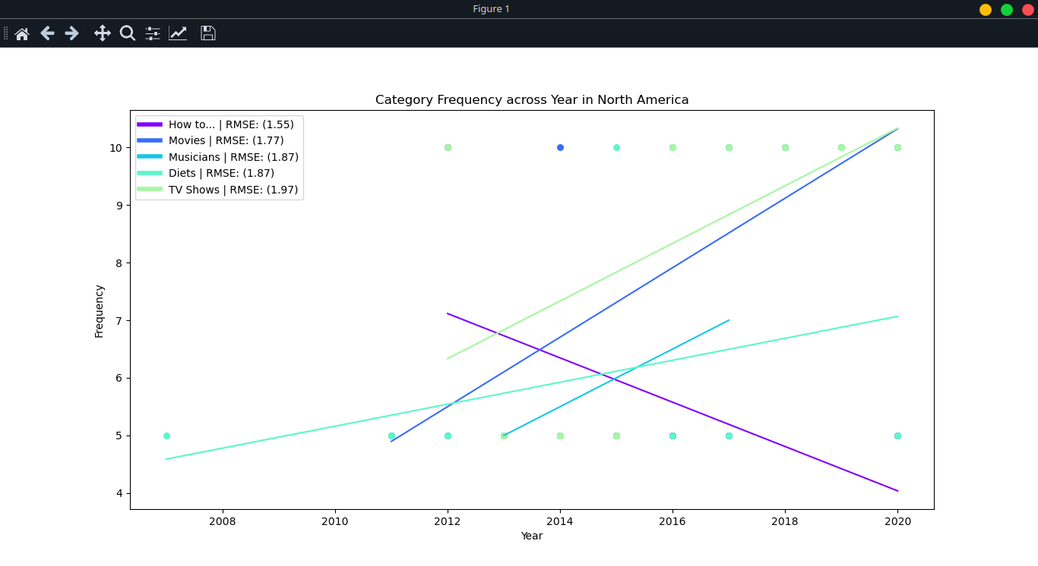

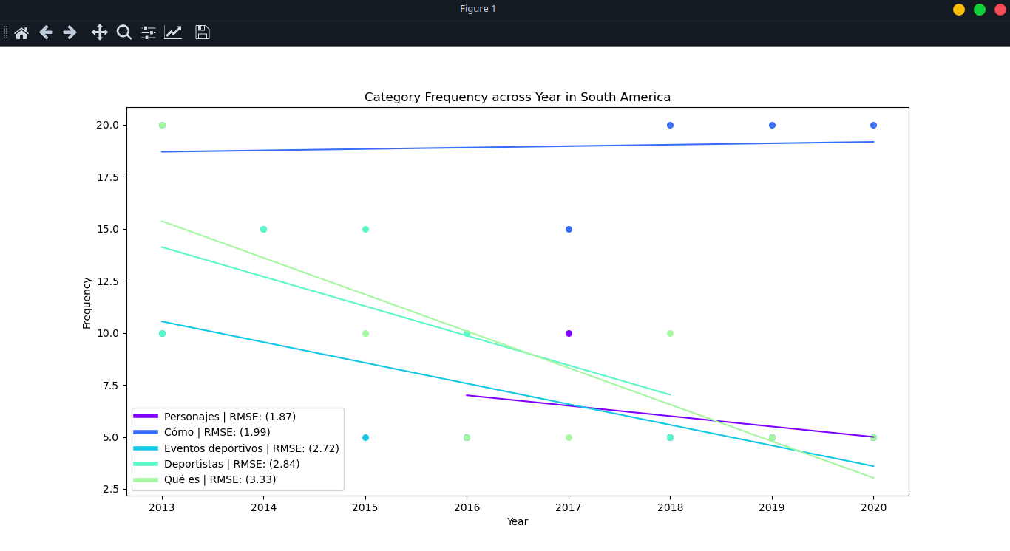

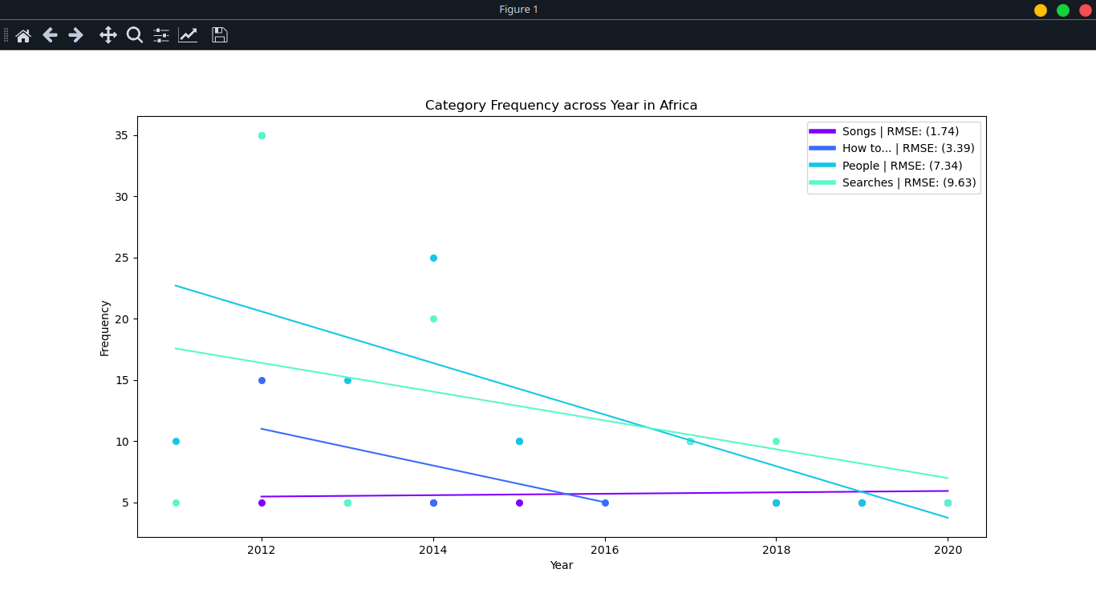

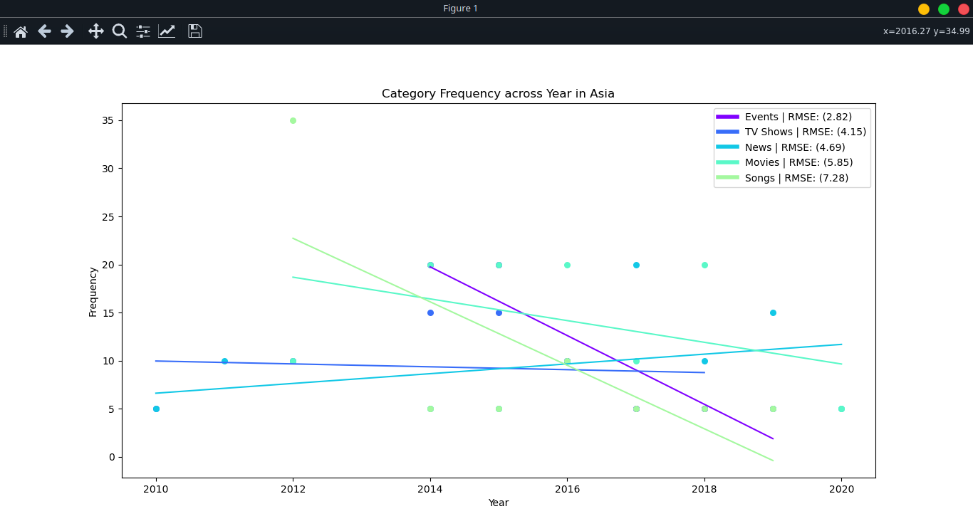

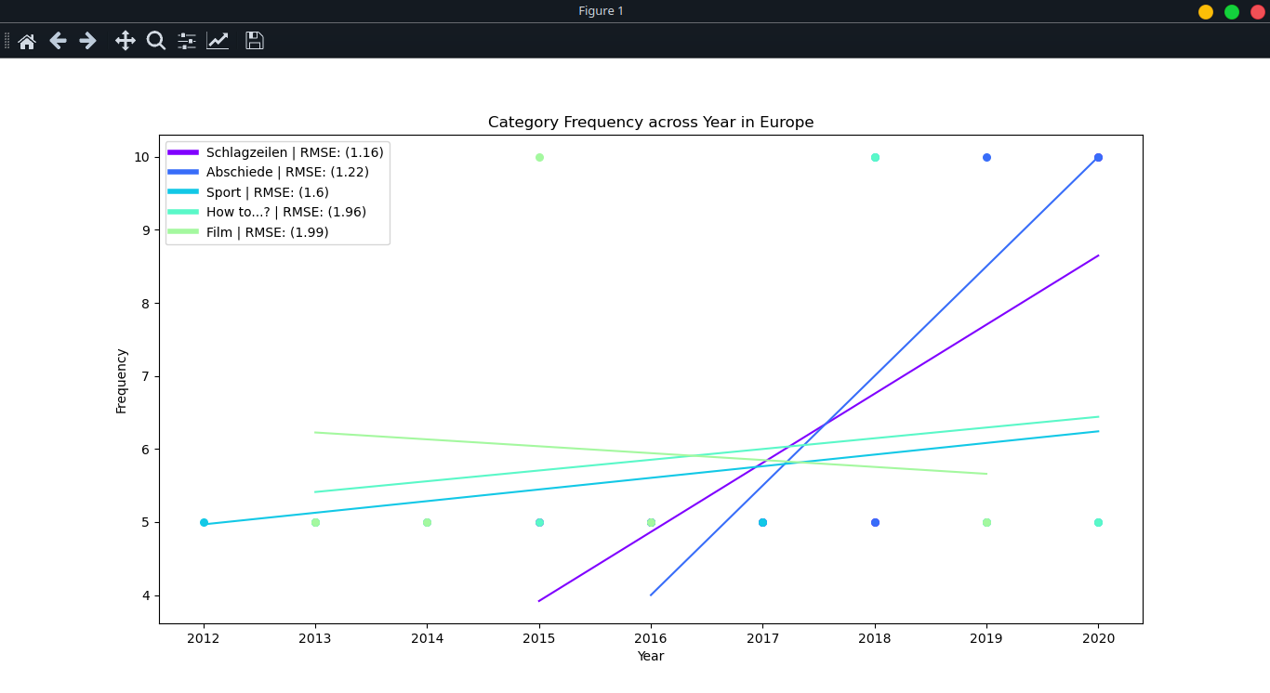

**Isotonic Regression:**

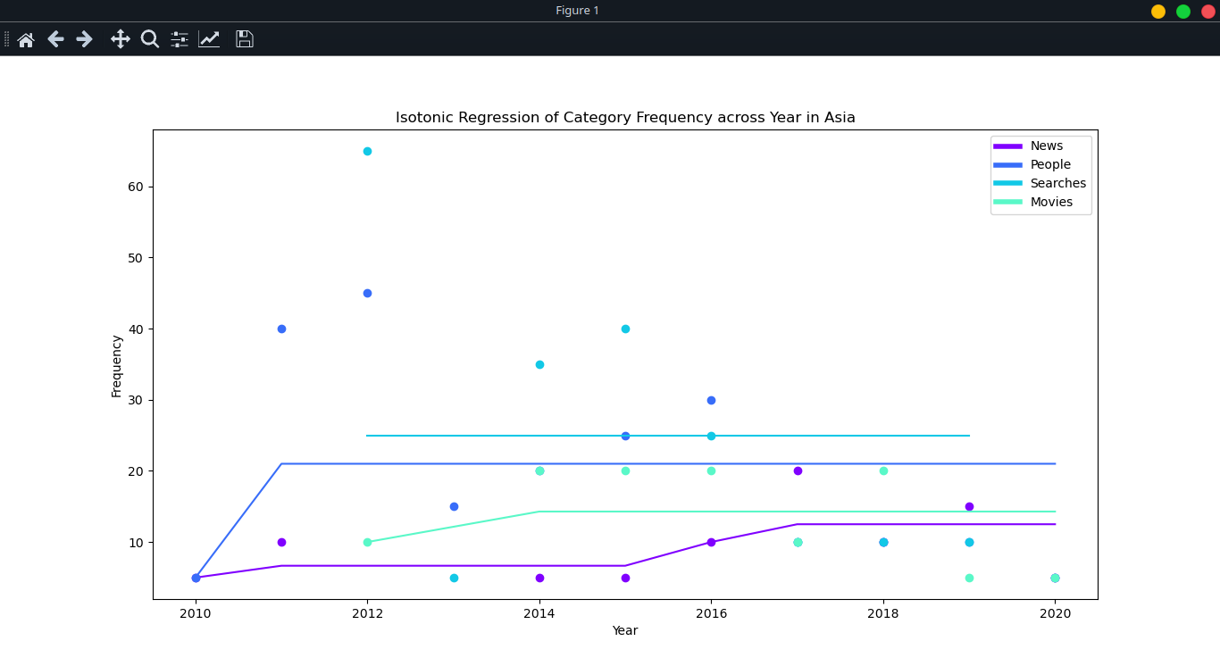

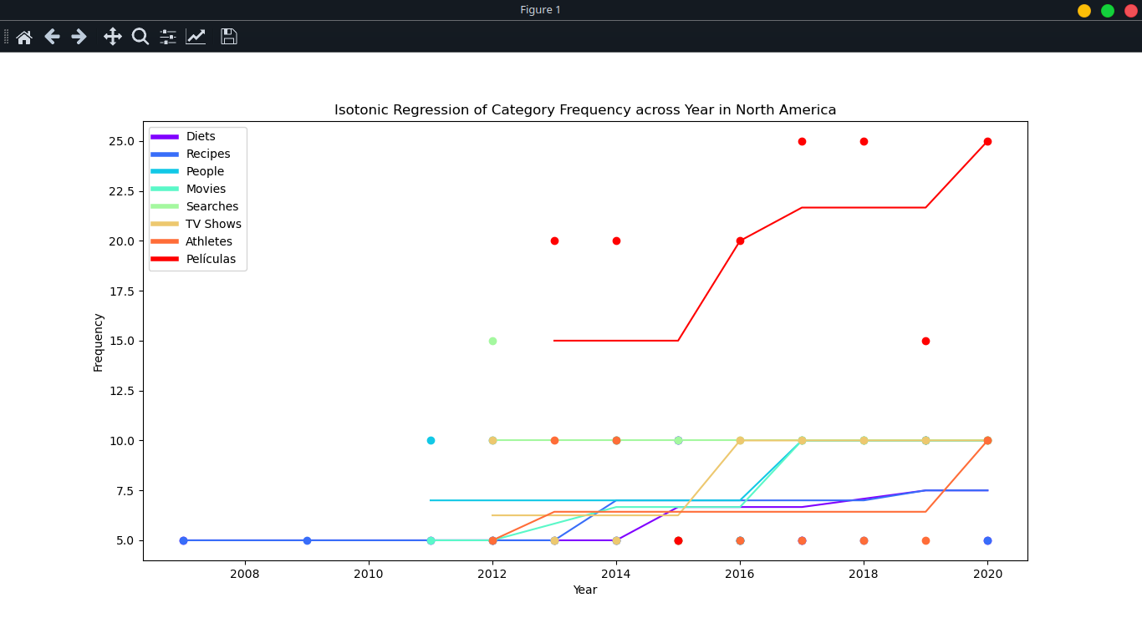

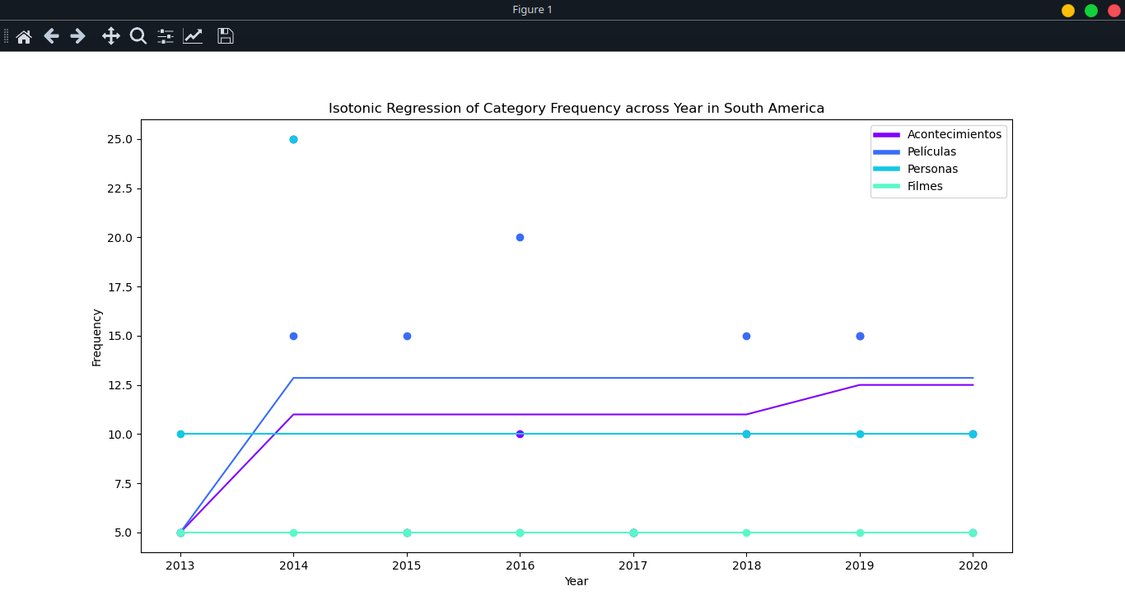

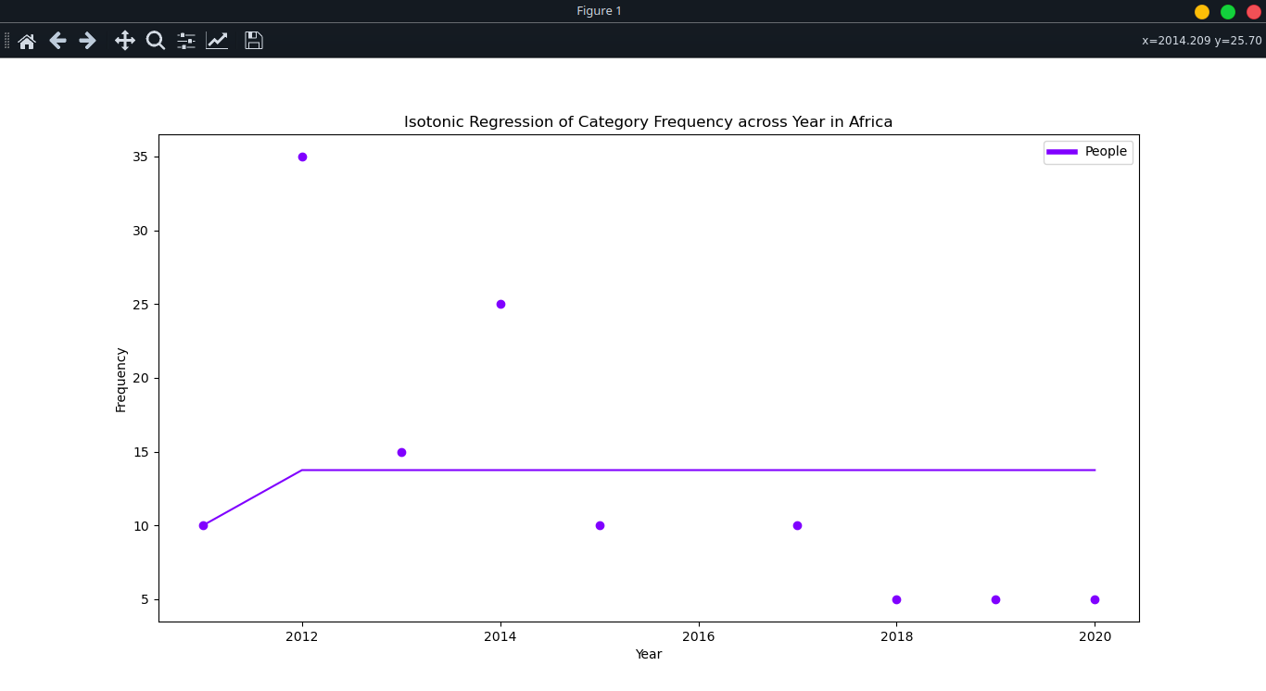

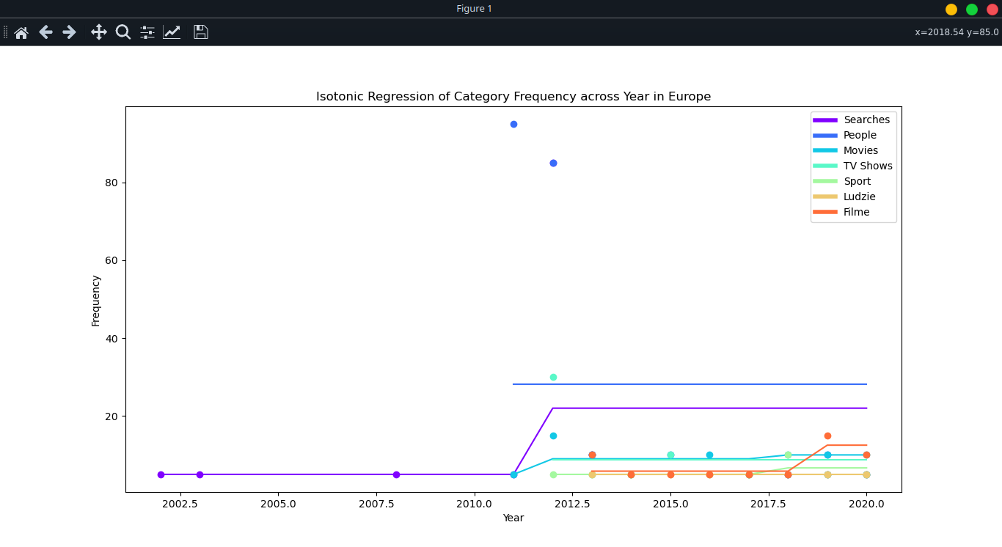

**6. Visualization Techniques used:**

For our Data Mining project, we have used various visualization techniques which were used in our Data modelling and Data exploration phase and are listed as follows:

1. Scatter plot

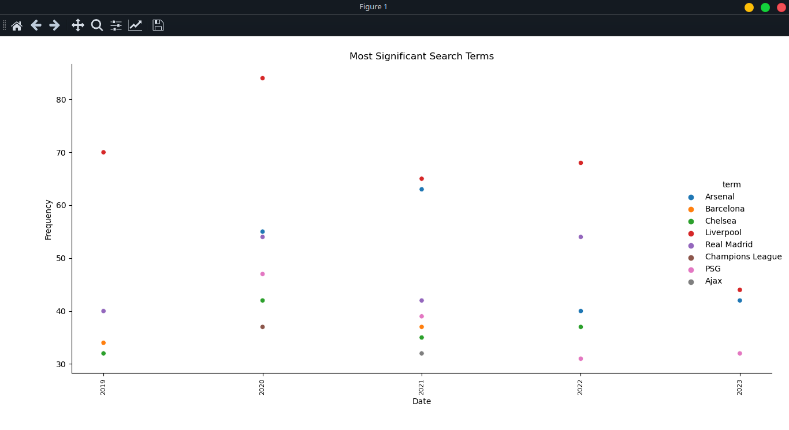



1. Line graph

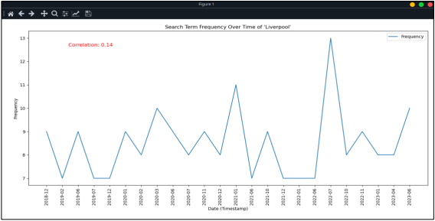

1. Bar graph

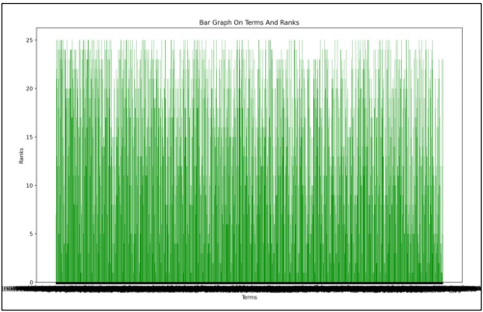

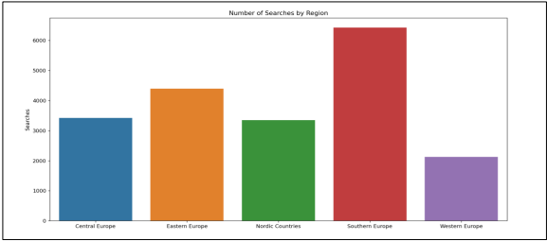

**7. Conclusion:**

We were able to discover and extract valuable insights from our data modelling techniques. As we used evaluation metrics to evaluate the correctness of our model, our model performed well than expected. As our datasets were random and were not collected for this purpose, still we were able to get some patterns from our data visualization and our model was able to get what was expected. Still more optimization is necessary as our model doesn’t perform well according to standard modelling criteria.

**8. Github Repository Link:**

<https://github.com/svarg1-unh/Fall-2023-Data-Mining/tree/main/Phase5>